**Optical Flow**

* [**Sparse Optical Flow: Lucas-Kanade method**](https://docs.opencv.org/master/d4/d8b/group__datasets__ar.html)

All the neighboring pixels will have similar motions. Lucas-Kanade method takes a 3x3 patch around the point. So all the 9 points have the same motion. We can find ($f_{x},f_{y},f_{t}$) for these 9 points. So now our problem becomes solving 9 equations with two unknown variables which are over-determined. A better solution is obtained with the least square fit method. Below is the final solution which is two equation-two unknown problems and solves to get the solution.

**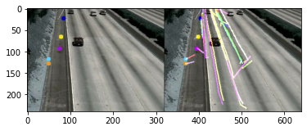**

* [**Horn–Schunck method**](https://github.com/lmiz100/Optical-flow-Horn-Schunck-method)

The Horn–Schunck method of estimating optical flow is a global method that introduces a global constraint of smoothness to solve the aperture problem. It assumes smoothness in the flow over the whole image. Thus, it tries to minimize distortions inflow and prefers solutions that show more smoothness.

|  |  |
| --- | --- |
|  |  |
| **C:\Users\Jiss\AppData\Local\Packages\Microsoft.Office.Desktop_8wekyb3d8bbwe\AC\INetCache\Content.MSO\EF0E7D72.tmp** | |

* [**Dense Optical Flow**](https://docs.opencv.org/master/d4/d8b/group__datasets__ar.html)

Dense Optical Flow computes the optical flow for all the points in the frame. It is based on Gunner Farneback's algorithm which is explained in "Two-Frame Motion Estimation Based on Polynomial Expansion" by Gunner Farneback.

